**Module 3**

**Assignment 1**

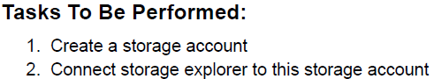

1. Create a Storage Account

az storage account create --name mod3azstrg1 --resource-group azmodulerg --location eastus --sku Standard_LRS

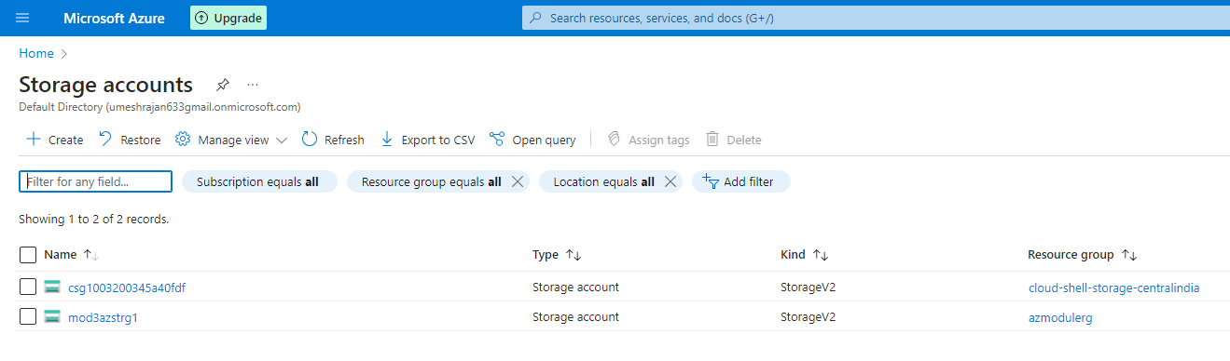

1. Download and Install Azure Storage Explorer, open it and Sign in with Azure. Once done, click on Connect to Azure resources.

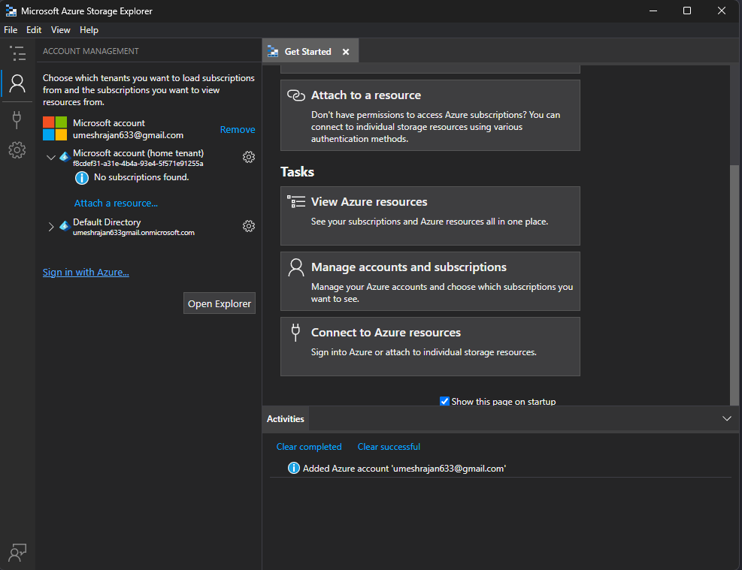

1. Connect by passing the necessary details. Azure Storage Account Name and Access Key as password.

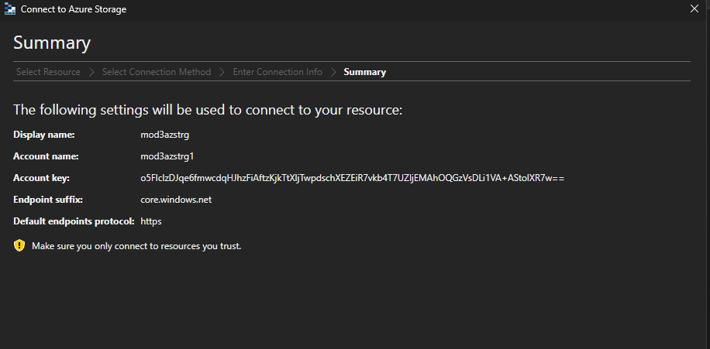

1. Once it’s connected, the storage account would be visible in the Storage Explorer App.

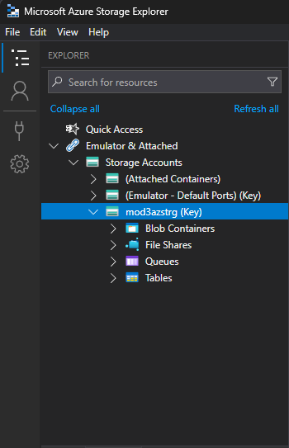

**Assignment 2**

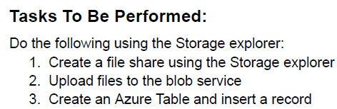

1. Create a File Share by right clicking on File Share under the Storage Account.

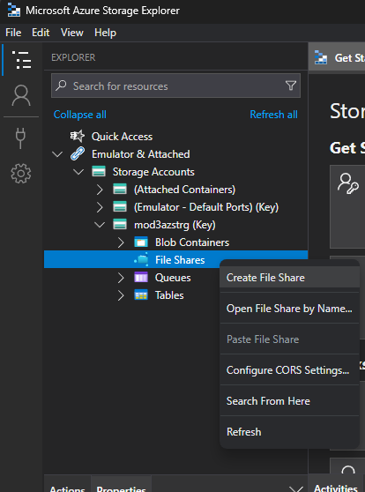

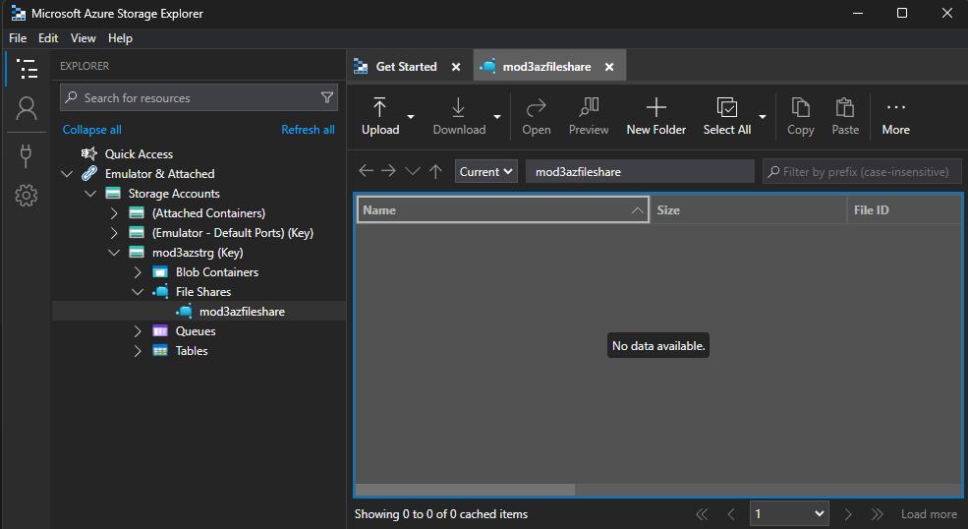

1. Create a Blob Container and upload a file.

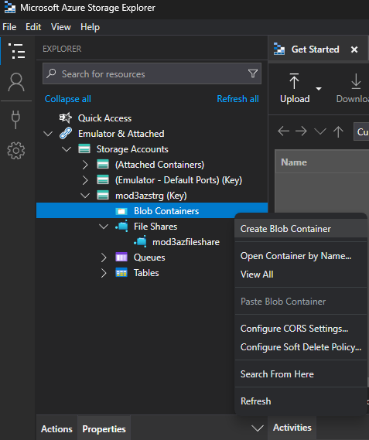

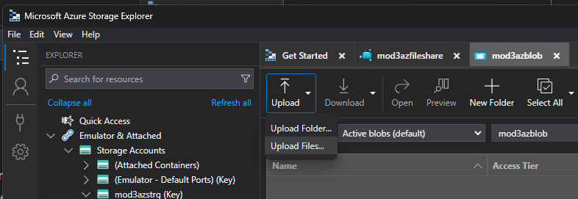

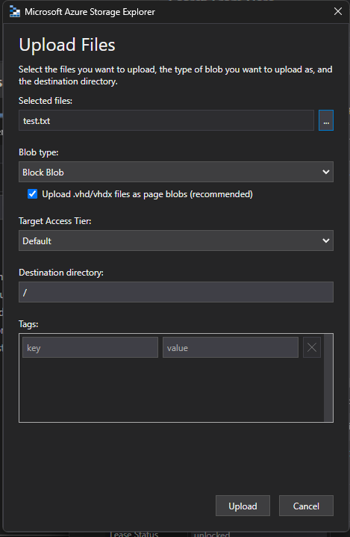

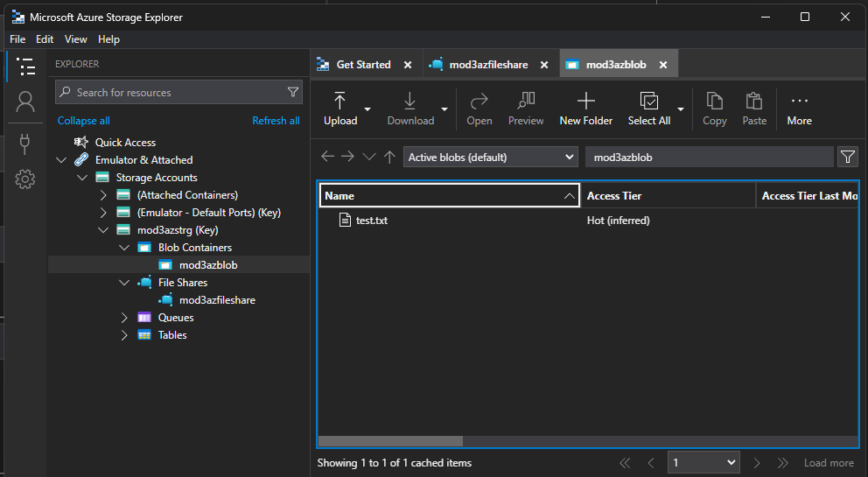

1. Create a Table and add.

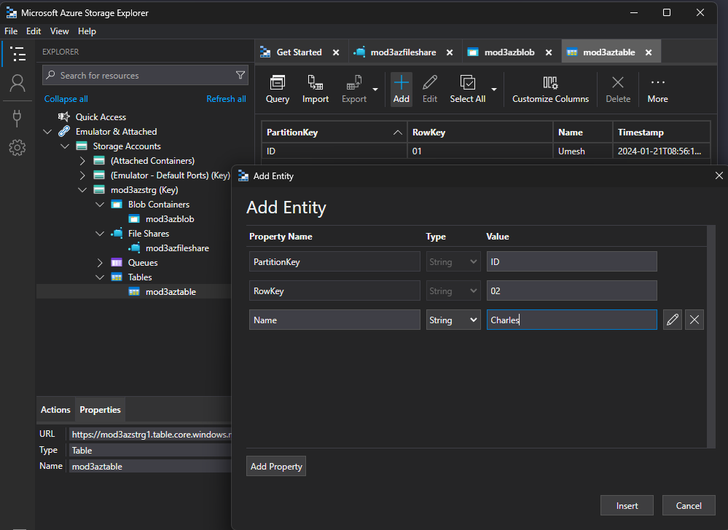

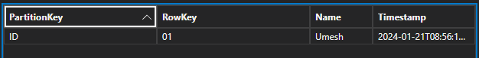

**Assignment 3**

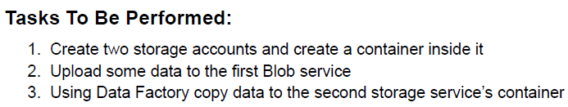

1. As the storage account is already created in previous assignment, utilize the one and create another one.

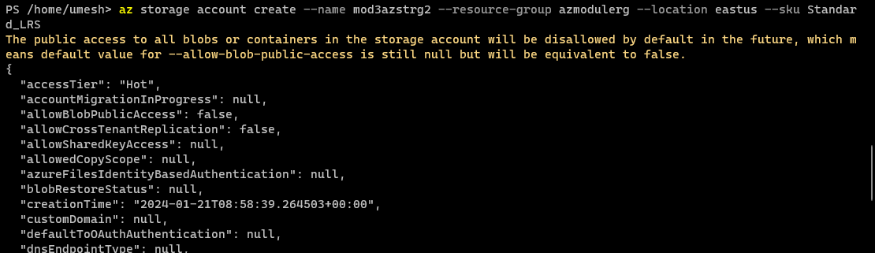

1. The blob container on the first one is already created. Utilize the one and use Data Factory service to copy the data to the second container.
2. Proceed with creating a container on the newly created storage account.

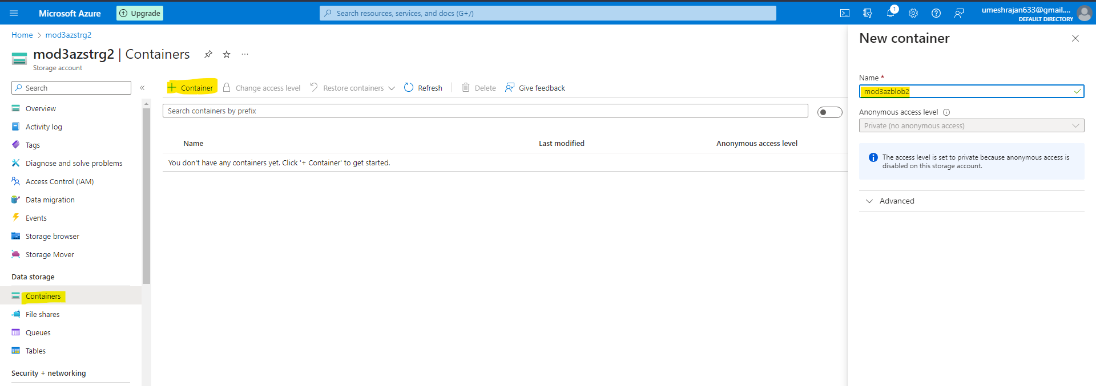

1. Search for Data Factories in the Azure Portal and create a new data factory.

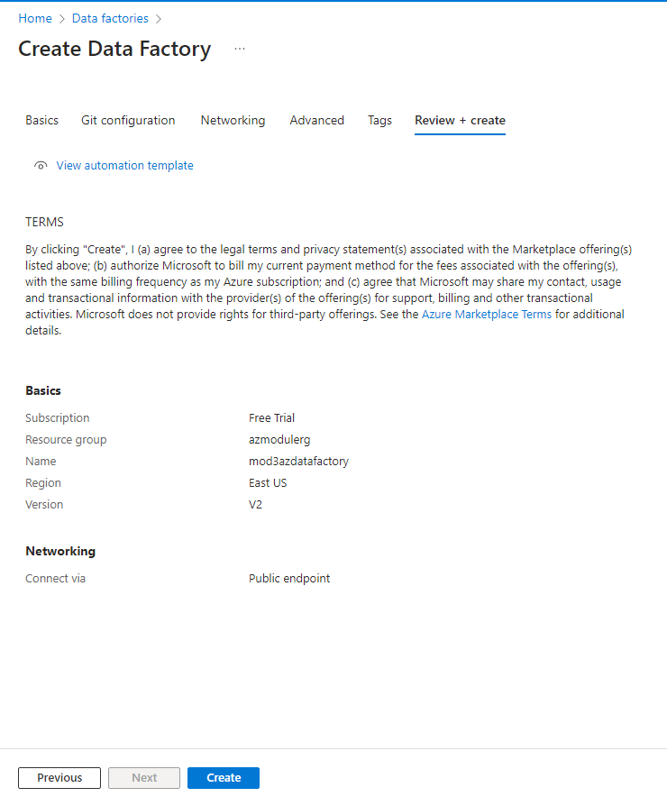

1. Once created, open the Data Factory Studio and go to Author Tab. Under Author Tab, create a new pipeline.

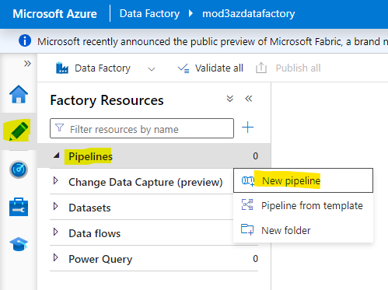

1. Drag the Copy Data into the Graph and click on Source to set the Source Storage Account to Copy the data from.

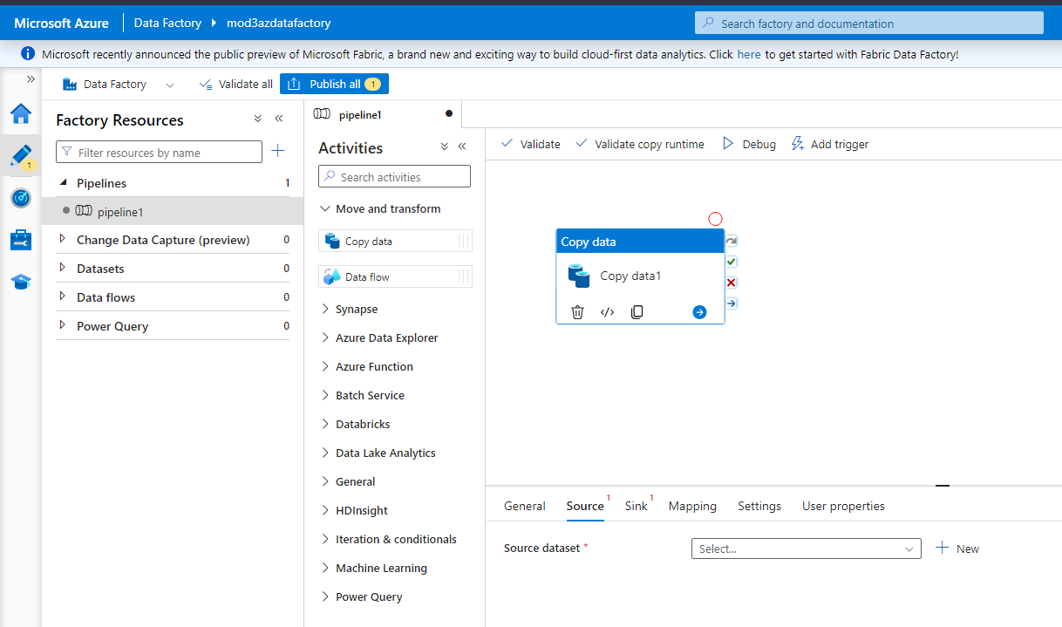

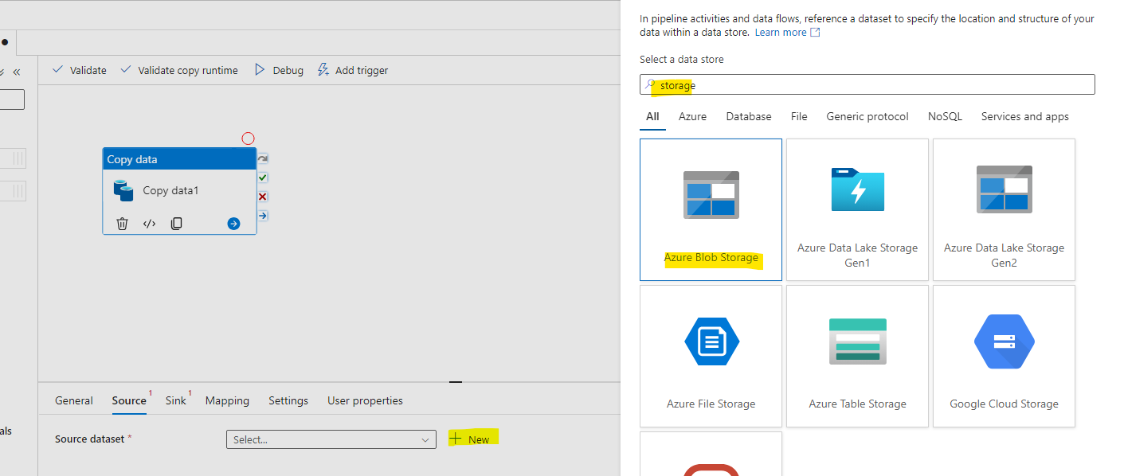

1. Choose the file format and all the other details.

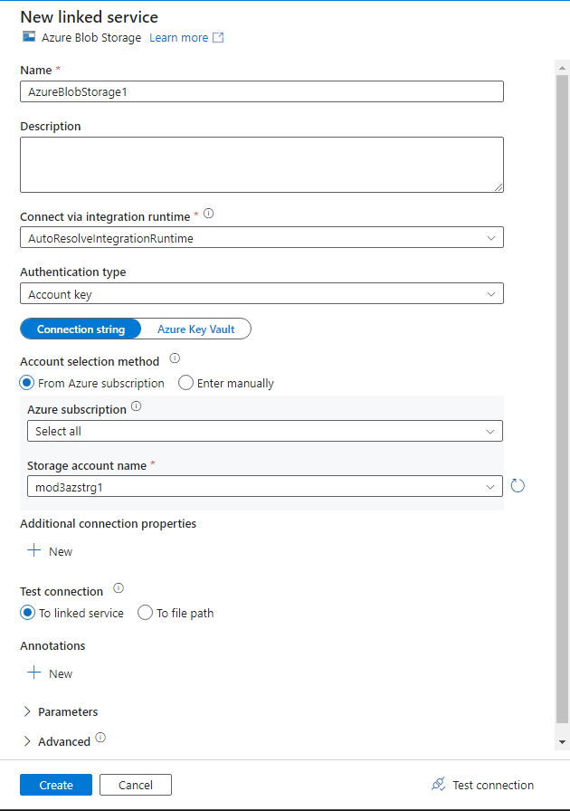

1. Follow the same for the Destination aswell.
2. After setting up the containers, run the pipeline to test.

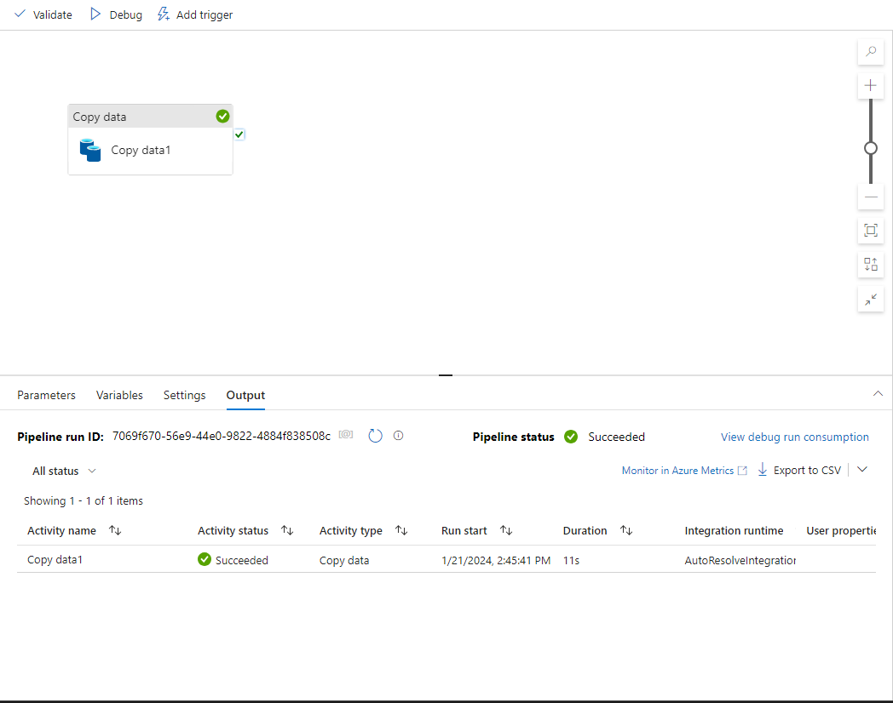

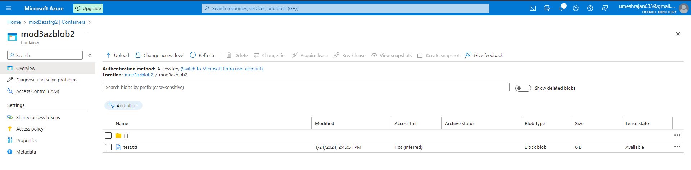

1. As observed, the copy data function is functioning properly via Data Factory.

**Assignment 4**

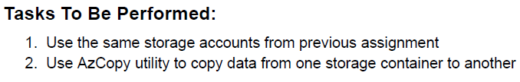

1. Download the AzCopy Tool from the Azure Website and Install it.
2. Pass on this command, get the source and destination path. If authorized, the below command will execute and copy from src to dest.

azcopy cp "https://mod3azstrg1.blob.core.windows.net/mod3azblob/" "https://mod3azstrg2.blob.core.windows.net/mod3azblob2/" --recursive=true S